7.2.8.12 Editors - 3D View - Header - Text - Edit mode - Edit menu
Edit Mode - Edit Menu 1
Cut 1
Copy 1
Paste 1
Paste File 1
Select All 1

Edit Mode - Edit Menu

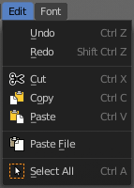

Cut
Cuts the selection.

Copy
Copies the selection.

Paste
Pastes a copied selection.

Paste File
Opens the file browser where you can choose a text file to paste the text from. It needs to be UTF8.

Select All
Selects all text.

